**CS5590VC Lab2 Report**

Jian Wang

09/04/2013

In Lab2 homework, I built a dynamic web page in jsFiddle letting users find the best driving route between two cities of USA, show it on Google maps. The technologies used here includes: Javascript, HTML5, CSS3, jQuery Mobile and Google Map services.

1. Initialize it, showing the title and current location (Kansas City) on Google map.

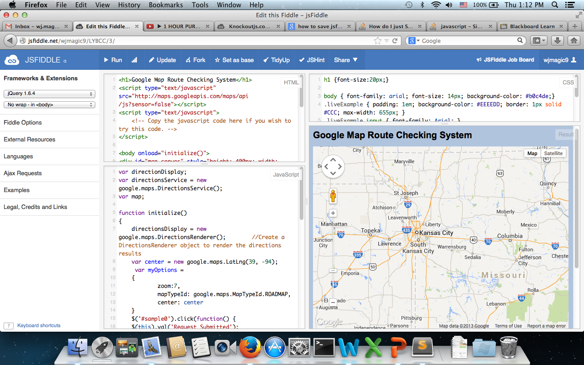

1. User can input starting point and ending point(city names)

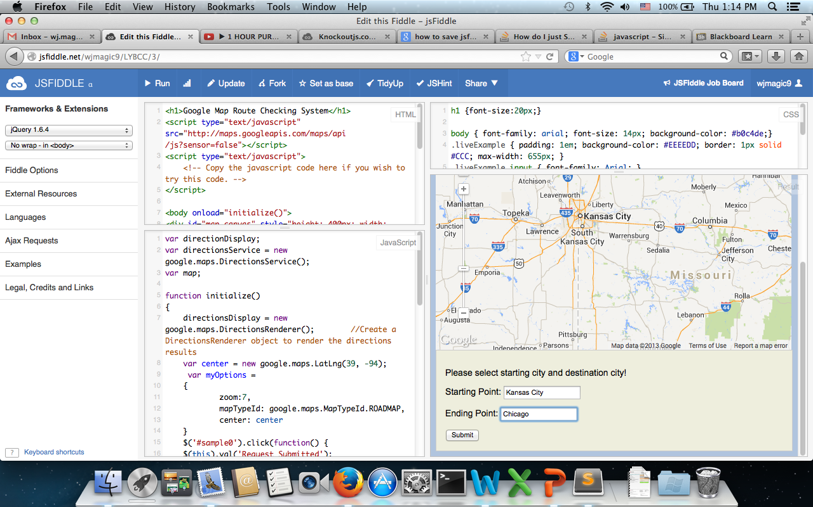

1. Click ”submit” button, which will become “Request Submitted”. And the right driving route will be shown on map.

